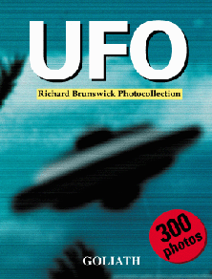 | UFO  Richard Brunswick Collection  English / Deutsch / Francais / Espanol / Italiano  size: 5,5 x 7,5 inches  320 pages / 300 photos  ISBN 3-9805876-3-0  price:  Just landed! The ultimate picture bible for every UFO fan, the most sensational and encompassing photodocument of the UFO century.  Over 300 "never before published" pictures of UFO's, scenes, contacts, evidence.....Fantastic !!! -Joe Meierson, NY.
  US$ 27.95
  £ 14.99
  EUR D 19,90
  EUR 22,90

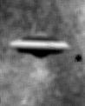  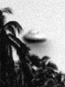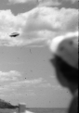 | 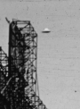  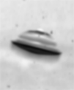   | 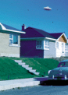  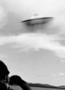 | |  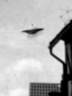  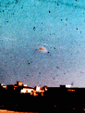 | 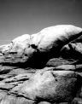    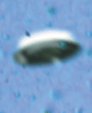 | 